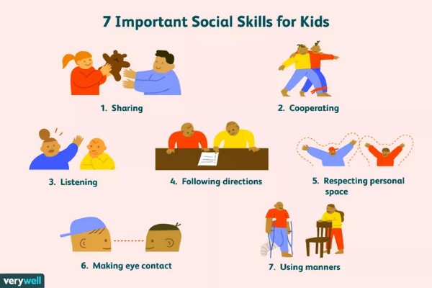

Good social skills allow kids to enjoy better peer relationships. Social skills are a set of skills that need ongoing refinement as your kids get older. Good social skills also can help kids have a brighter future. Look for teachable moments where you can help your kids do better.

Researchers from Penn State and Duke University found that children who were better at sharing, listening, cooperating, and following the rules at age five were more likely to go to college. They also were more likely to be employed full-time by age 25.

Children who lacked social and [emotional skills](https://www.verywellfamily.com/how-to-teach-kids-about-feelings-1095012) were more likely to have substance abuse issues, relationship issues, and legal trouble. They were also more likely to depend on public assistance.

The good news is that social skills can be taught. Start with the most basic social skills first and keep sharpening your child’s skills over time. Over the next weeks, we will discuss the most important social skills for kids to learn and how you can help teach them.

1. **Sharing** 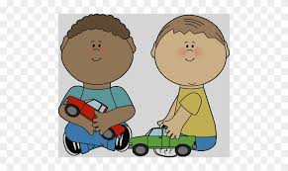

A willingness to share a snack or share a toy can go a long way to helping kids [make and keep friends](https://www.verywellfamily.com/helping-your-child-make-new-friends-621097). Overall, studies show children who feel good about themselves are more likely to share. Sharing also makes them feel good about themselves so teaching them to share may be key to boosting their self-esteem.

**How to Practice**

While you may not want to [force your child to share](https://www.verywellfamily.com/forcing-your-kid-to-share-4126426) certain toys or with certain children, you can regularly point out sharing when you see it. Praise your child for sharing and indicate how it makes others feel. Say something like, “You chose to share your snack with your sister. I bet she feels happy about that. That’s a nice thing to do.” Also model sharing when opportunities for sharing occur, point it out as you model for your child.

1. **Cooperating** 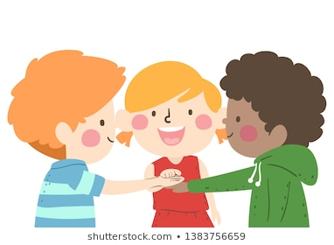

Cooperating means working together to achieve a common goal. [Kids who cooperate](https://www.verywellfamily.com/parenting-an-oppositional-child-2764635) are respectful when others make requests. They also contribute, participate, and help out. Good cooperation skills are essential for successfully getting along within a community.

**How to Practice**

Talk about the importance of teamwork and how jobs are better when everyone pitches in. Create opportunities for the whole family to work together. Whether you assign everyone a specific job when you’re making a meal or you assign specific chores that are integral to the family, emphasize the importance of cooperation.

1. **Listening**  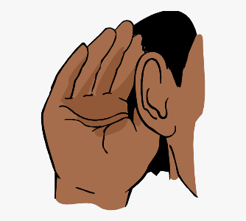

Listening isn’t just about staying quiet—it means really absorbing what someone else is saying. Listening also is a critical component of healthy communication. After all, much of the learning in school depends on a child’s ability to listen to what the teacher is saying.

**How to Practice**

When reading a book to your children, periodically stop and ask them to tell you about what you’re reading. Pause and say, “Tell me what you remember about the story so far.” Help them fill in any gaps they're missing and encourage them to keep listening as you continue. Additionally, don’t allow them to interrupt others when they’re talking.

1. **Following Directions** 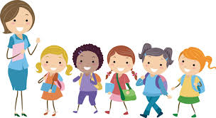

Kids who struggle to follow directions are likely to experience a variety of consequences.

Before you can expect your child to get good at following directions, however, it’s essential that you become well-versed in [giving directions](https://www.verywellfamily.com/kids-dont-listen-change-how-you-give-directions-1094955).

For example, don’t give a young child more than one direction at a time. Instead of saying, “Pick up your shoes, put your books away, and wash your hands,” wait until the shoes are picked up before giving the next command.

Another [mistake to avoid](https://www.verywellfamily.com/mistakes-parents-make-when-giving-kids-directions-1094795) is phrasing your directions as a question. Asking, “Would you please pick up your toys now?” implies that your kids have the option to say no. Once you’ve given your children directions, ask them to repeat back what you said. Ask, “What are you supposed to do now?” and wait for them to explain what they heard you say.

**How to Practice**

Praise your child for following directions by saying things like, “Thank you for turning off the TV the first time I told you to.” If your children struggle to follow directions, give them opportunities to practice following simple commands. Say things like, “Please pass that book to me,” and then provide immediate praise for following directions.

1. **Respecting Personal Space** 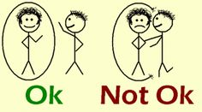

Some kids are close talkers. Others crawl into the laps of acquaintances without any idea that the other individual feels uncomfortable. It’s important to teach kids how to respect other people’s personal space.

Create household rules that encourage kids to respect other people’s personal space. “Knock on closed doors,” and “Keep your hands to yourself,” are just a few examples.

If your child grabs things out of people’s hands or pushes when impatient, establish consequences. If your child climbs into the laps of acquaintances or stands too close to people while talking, use it as a teachable moment. Take your child aside and provide some coaching about personal space issues.

**How to Practice**

Teach your children to stand about an arm's length away from people when they're talking. When they're standing in line, talk about how close to be to the person in front of them and talk about keeping their hands to themself. You might role-play various scenarios to help them practice describing appropriate personal space.

1. **Making Eye Contact** 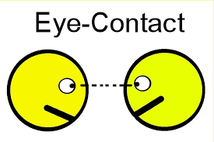

Good eye contact is an important part of communication. Some kids struggle to look at the person they’re speaking to. Whether your child is shy and prefers to stare at the floor or simply won’t look up when engrossed in another activity, emphasize the importance of good eye contact.

If your child struggles with eye contact, offer quick reminders after the fact. In a gentle voice, ask, “Where should your eyes go when someone is talking to you?” You don't want to cause a shy child additional anxiety. And provide praise when your child remembers to look at people when they’re talking.

**How to Practice**

You might even show your children how it feels to hold a conversation with someone who isn’t making eye contact. Ask them to share a story while you stare at the ground, close your eyes, or look everywhere except for at them. Then, invite them to tell another story and make appropriate eye contact while they're talking. Afterward, discuss how it felt in each scenario.

1. **Using Manners** 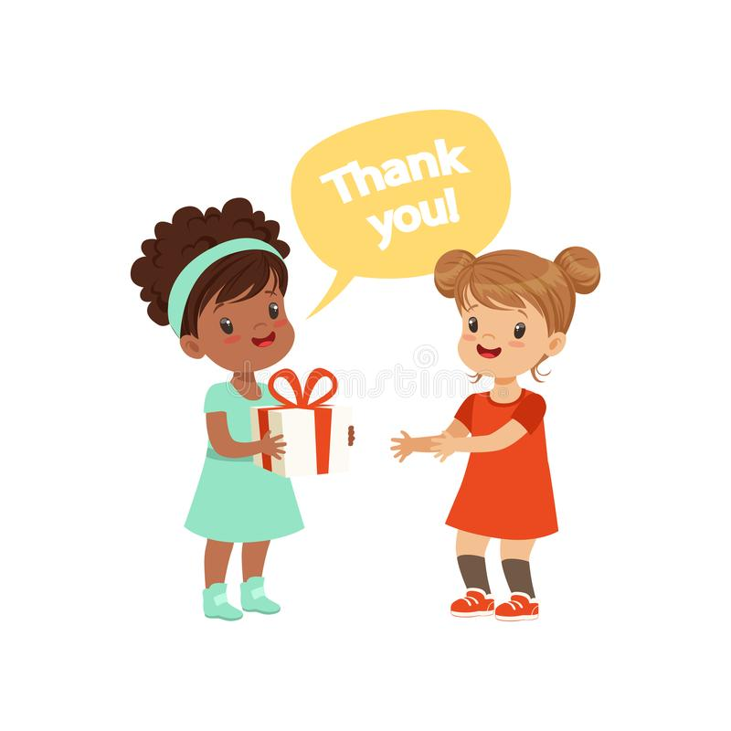

Saying please and thank you and using good table manners can go a long way toward helping your child gain attention for the right reasons. Teachers, other parents, and other kids will respect a well-mannered child.

Of course, [teaching manners](https://www.verywellfamily.com/ways-to-teach-kids-old-fashioned-manners-in-todays-world-1094897) can feel like an uphill battle sometimes. From burping loudly at the table to acting ungratefully, all kids will let their manners go out the window sometimes.

It is important, however, for kids to know how to be polite and respectful—especially when they’re in other people’s homes or at school.

**How to Practice**

Be a good role model with your manners. That means saying, “No, thank you,” and “Yes, please,” to your child on a regular basis. And make sure to use your manners when you’re interacting with other people. Offer reminders when your children forget to use manners and praise them when you catch them being polite.

Source: <https://www.verywellfamily.com/seven-social-skills-for-kids-4589865>